

*a project of Temple Rodef Shalom, Falls Church, VA*

**BLESSINGS AND RESOURCES FOR WELCOMING SHABBAT**

**Giving of Tzedakah Before Shabbat**

May we, together with all our people,

Respond to the needs of others.

From the fruits of our harvest this week,

We share with others.

And so we gain blessing:

Our lives have meaning,

Our lives have love.

As You greet us with Your angels on Shabbat,

May we be Your messengers to the world.

**The Blessing for Lighting the Shabbat Candles**

*Baruch Atah Adonai, Eloheinu Melech haolam   
Asher kid'shanu b'mitzvotav v'zivanu l'hadlik ner shel Shabbat*   
  
Blessed are You, Eternal our God, Sovereign of time and space.   
You hallow us with Your mitzvot and command us to kindle the lights of Shabbat.

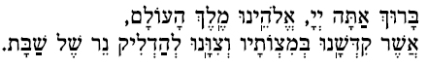

**Welcoming Song**

**(Shalom Aleichem / Ma Yafeh Hayom / Bim Bom)**

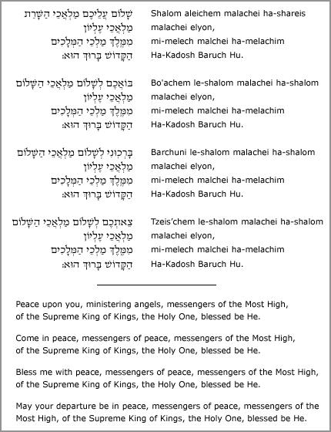

מַה יַפֶה הַיוֹם

שַׁבָּת שָׁלוֹם

Mah ya-feh hayom

Shabbat Shalom

*How beautiful this day is!*

*Shabbat Shalom*

**Family Blessings**

**Blessing the Spouse/Partner/Parent**

**In Praise of A Woman:**

***Eishet Chayil* – A Woman of Valor (Proverbs 31)**

A Woman of valor, seek her out;

she is to be valued above rubies.

She opens her hand to those in need

and extends her help to the poor.

Adorned with strength and dignity,

she faces the future cheerfully.

Her speech is wise; the law of kindness is on her lips.

Those who love her rise up with praise and call her blessed:

“Many have done well, but you surpass them all.”

Charm is deceptive and beauty short-lived,

but a woman loyal to God has truly earned praise.

Honor her for all of her offerings;

her life proclaims her praise.

**In Praise of A Man:**

***Ashrei Ish* – Blessed is the Man**

Blessed is the man who reveres Adonai,

Who greatly delights in God’s commandments!

His descendants will be honored in the land

the generation of the upright will be blessed.

His household prospers, and his righteousness endures forever.

Light dawns in the darkness for the upright;

for the one who is gracious, compassionate and just.

He is not afraid of evil tidings;

his mind is firm trusting in Adonai.

His heart is steady, he will not be afraid.

He has distributed freely,

he has given to the poor;

his righteousness endures forever;

his life is exalted in honor.

**Blessing over Children**

Blessed is the parent and blessed is the child when our hearts are turned toward one another.

Blessed is the home filled with laughter and light, and joyful spirit of Shabbat.

Blessed is the home when, even in difficult times, we can fill it with the light of Shabbat.

Blessing for boys**For Boys**

*Y'simcha Elohim   
k'Efrayim v'chi-Menasheh.*

May God make you like Ephraim and Menasheh

# blessing for girlsFor Girls

*Y'simeich Elohim   
k'Sarah, Rivkah, Rachel, v'Leah.*

May God make you like Sarah, Rebecca, Rachel and Leah.

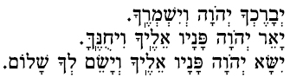**For All**

*Y'va-re-ch’-cha Adonai V'yish-m'-re-cha.   
Ya'er Adonai panav ei-le-cha vi-chu-ne-ka.   
Yisa Adonai panav eilecha v'yasem l'cha shalom.*May God Bless you and guard you.   
May the light of God shine upon you, and may God be gracious to you.   
May the presence of God be with you and give you peace.

**Child Blessing for the Parents**

*Adonai y’varech et a-hav-TA-nu*

May God bless our love for each other! יְיָ יְבָרֶךְ אֶת אָהַבְתָנוּ



# The Blessing for the Bread (Challah)

blessing over challah

*Baruch Atah Adonai, Eloheinu Melech ha-olam,   
Ha-motzi le-chem min ha-aretz.*   
  
Our praise to You, Eternal our God, Sovereign of the universe,   
Who brings forth bread from the earth.

|  |
| --- |
|  |

**Z’mirot (Shabbat Table Songs)**

**BIM BOM**

Bim bom, bim bim bim bom

Bim bim bim bim bim bom...

Shabbat shalom (hey!)

Shabbat shalom (hey!)

Shabbat, Shabbat, Shabbat, Shabbat shalom...

***Birkat Hamazon* – Blessing After the Meal**

**Leader:**

*Chaveirai nvareich  
Chaveirai n'vareich!*

Let us praise God!

**Group:**

*Yhi shem Adonai  
Y'hi shem Adonai m'vorach mei-atah v'ad olam.*

Praised be the name of God, now and forever.

**Leader:**

*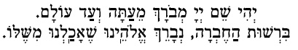  
Y'hi shem Adonai m'vorach me-atah v'ad olam.   
Birshut hachevrah, n'vareich Eloheinu she-achalnu mishelo.*

Praised be the name of God, now and forever.   
Praised be our God, of whose abundance we have eaten.

**Group:**

*Baruch Eloheinu  
Baruch Eloheinu she-achalnu mishelo uv'tuvo chayinu.*

Praised be our God, of whose abundance we have eaten, and by whose goodness we live.

**Leader:**

*Baruch Eloheinu  
Baruch Eloheinu she-achalnu mishelo uv'tuvo chayinu. Baruch hu uvaruch sh'mo.*

Praised be our God, of whose abundance we have eaten, and by whose goodness we live. Praised be the Eternal God.

**All:**

*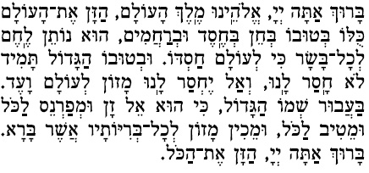  
Baruch atah Adonai, Eloheinu Melech haolam,   
hazan et haolam kulo b'tuvo, b'chein b'chesed uv'rachamim.   
Hu notein lechem l'chol basar ki l'olam chasdo.   
Uv'tuvo hagadol tamid lo chasar lanu,   
v'al yechsar lanu, mazon l'olam va-ed,   
baavur sh'mo hagadol.   
Ki hu El zan um'farneis lakol umeitiv lakol,   
umeichin mazon l'chol b'riyotav asher bara.   
Baruch atah Adonai, hazan et hakol.*

Sovereign God of the universe, we praise You: Your goodness sustains the world. You are the God of grace, love, and compassion, the Source of bread for all who live; for Your love is everlasting. In Your great goodness we need never lack for food; You provide food enough for all. We praise You, O God, Source of food for all who live.

*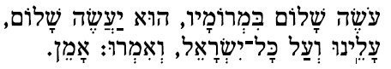  
Oseh shalom bimromav, hu yaaseh shalom,   
aleinu v'al kol Yisrael, v'imru amen.   
Adonai oz l'amo yitein, Adonai y'vareich et amo vashalom.*

May the Source of peace grant peace to us, to all Israel, and to all the world. Amen. May the Eternal grant strength to our people. May the Eternal bless our people with peace.

*Adonai oz  
Adonai oz l'amo yitein, Adonai y'vareich et amo vashalom.*

Eternal God: give strength to Your people; Eternal God: bless Your people with peace.